eTwinning contact seminar for Primary school teachers
How to start your first eTwinning project?
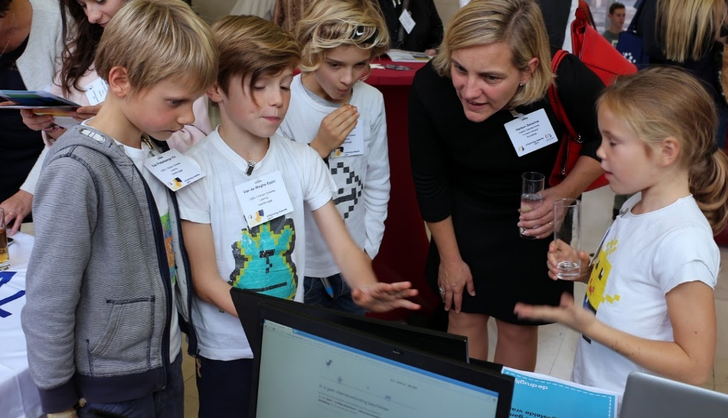
GHENT BELGIUM 22/23/24 NOVEMBER 2018

Hotel & venue
Novotel Centrum
Ghent
Please bring your own devices

Thursday 22 November

14.00-15.00 | Registration and welcome coffee
15.00-16.00 | Welcome - Plenary opening session  - Welcome – National Support Service Belgium Flemish Community a  - Key Note speech: eTwinning project in primary schools - Anne Gilleran (Central Support Service (tbc)  - eTwinning in primary schools: tips and tricks from ambassadors (video) (tbc)
16.00-16.30 | Networking activity: getting to know each other
16.30-17.00 | Coffee break
17.00-18.00 | Networking activity: getting to know each other and exploring themes
20.00-22.00 | Diner @ the hotel

Friday 23 November

9.30-11.00 | Workshop: Project examples en project ideas  (presentations by ambassadors)
11.00-12.30 | Workshop: project ideas – group work
12.30-14.00 | Lunch
14.00-14.30 | Tips for project planning  Presentation by NSS
14.30-16.00 | Workshop: project planning - group work
16.00-20.00 | Networking time  Option: City tour with an ambassador
20.00-22.00 | Diner in the City centre

Saturday 24 November

9.30-11.00 | Workshop: Project planning – Feedback round
11.00-12.30 | Workshop: Project planning - Group work
12.30-13.00 | Closing of the seminar - Plenary session
13.00 | End of the seminar

More information
Target group: teachers from primary education - registration in eTwinning is necessary – project experience is not required

Goals of the seminar:
- Get to know eTwinning and added value for primary schools
- Learn how to plan and manage a first eTwinning project
- Build your eTwinning network
- Start your (first) eTwinning projects

Contact your National Support Service for further details

Registration: http://bit.ly/seminar_ghent

